**Exercise 1- Hello World**

**Step 1 docker run hello-world:** 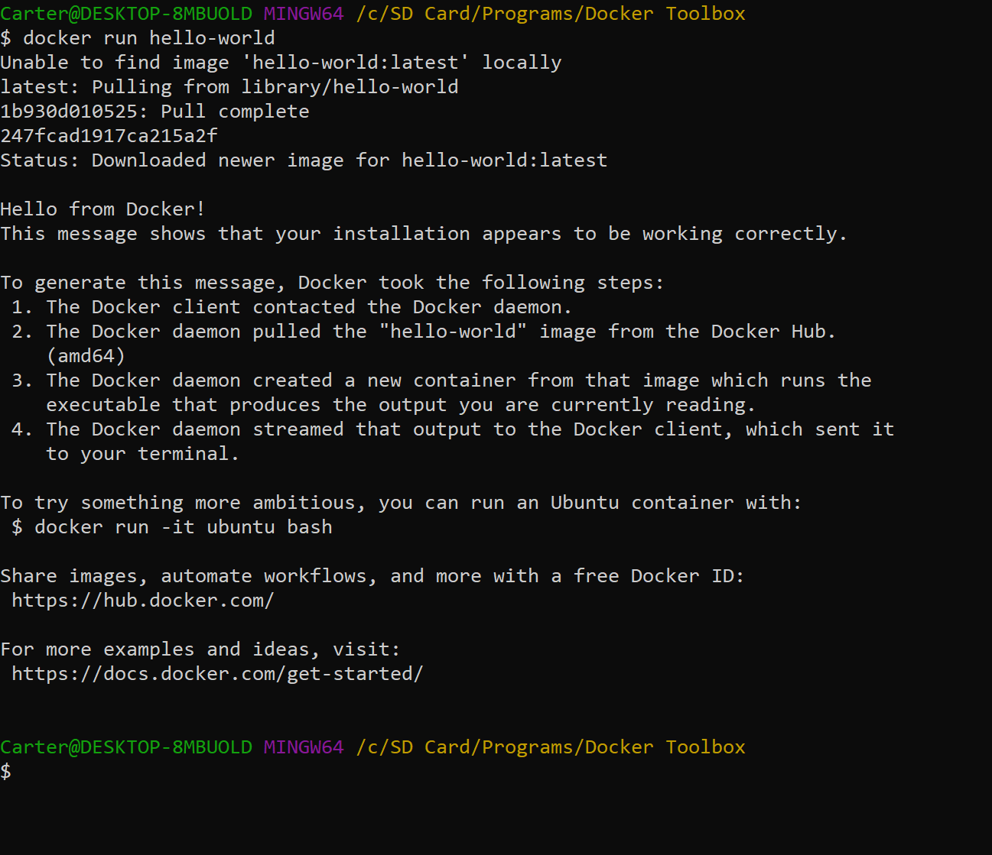

**Step 2 docker images:**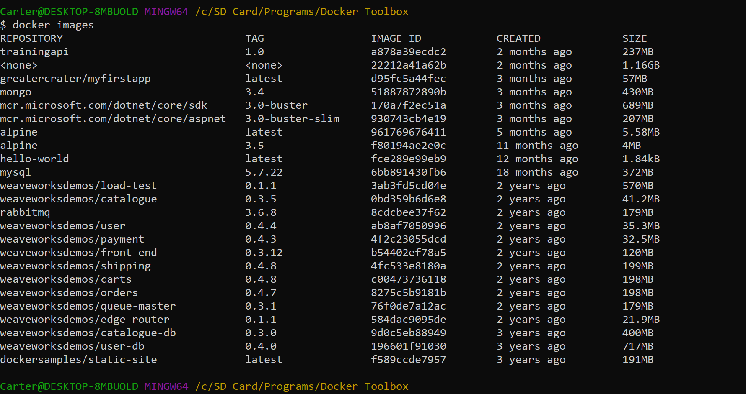

**Step 3 docker ps -a:** 

**Exercise 2- Running a Container**

$ docker pull alpine

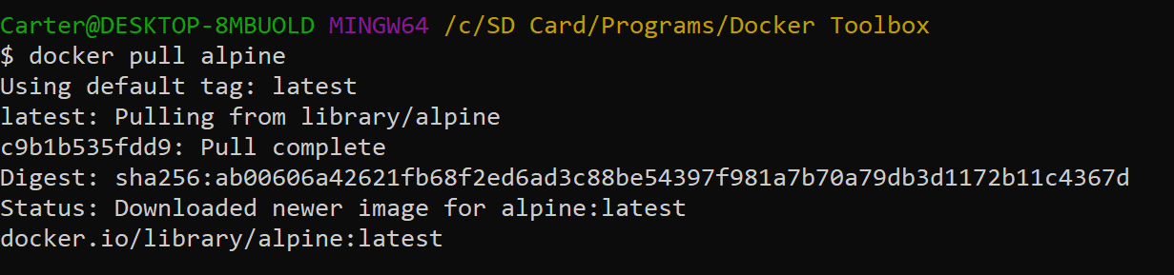

$ docker run alpine ls -l

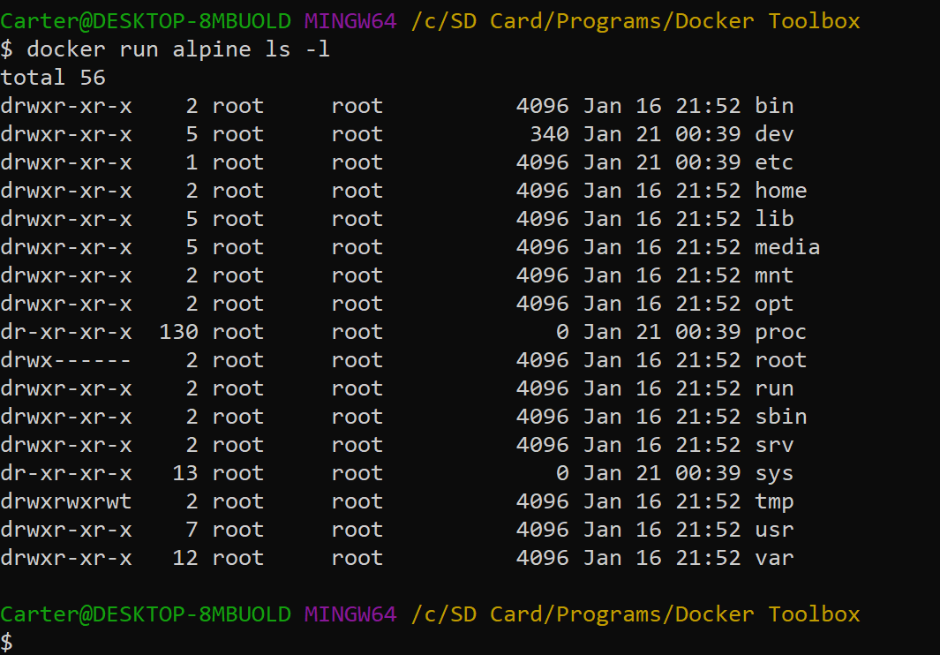

$ docker run alpine echo "hello from alpine"

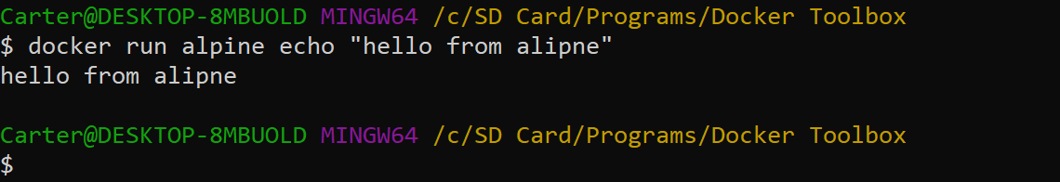

$ docker run alpine /bin/sh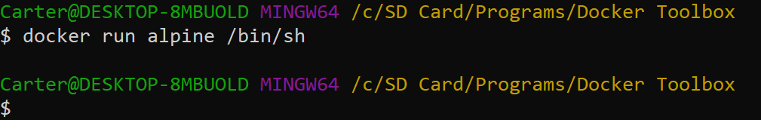

$ docker run -it alpine /bin/sh 

 ls -l, uname -a, and exit

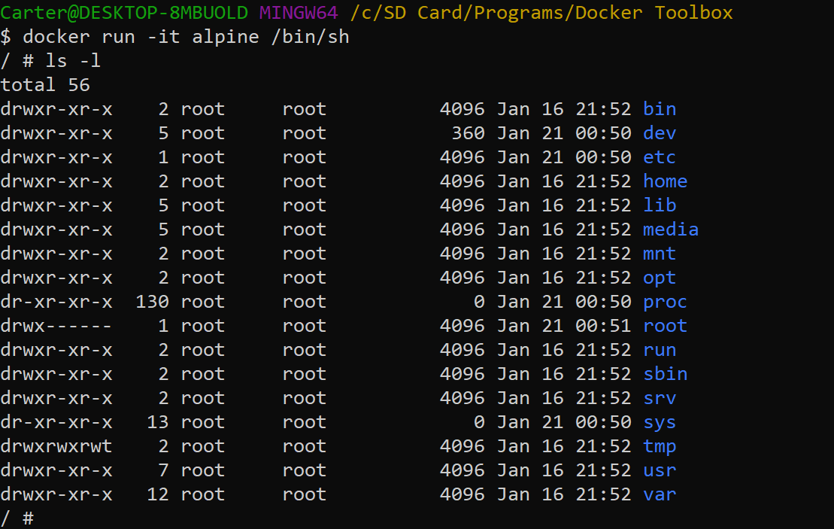  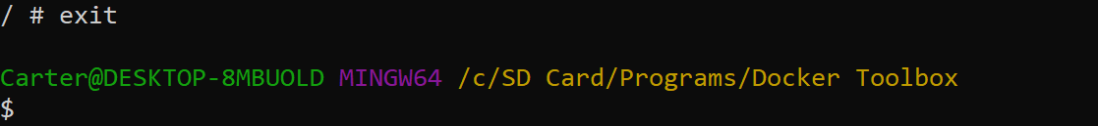

$ docker ps

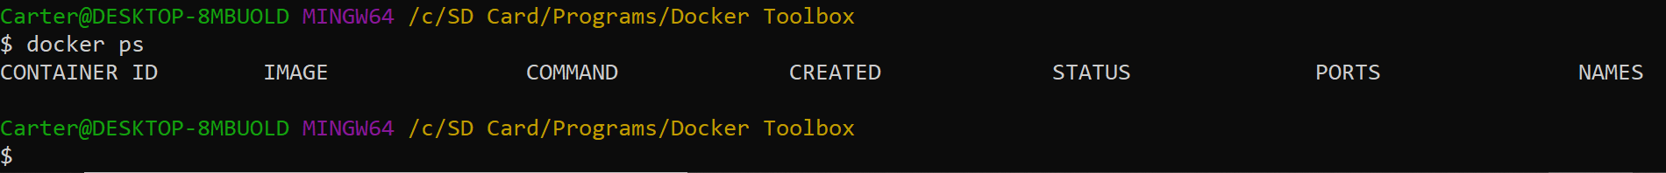

docker ps -a 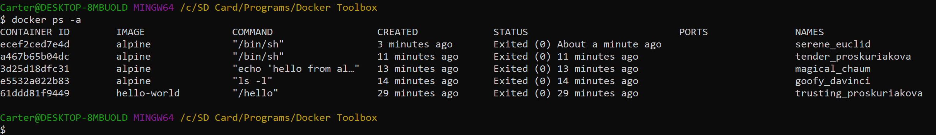

**Exercise 3- Sample Web Application in Container**

**2.1 Static Sites**

$ docker run -d dockersamples/static-site

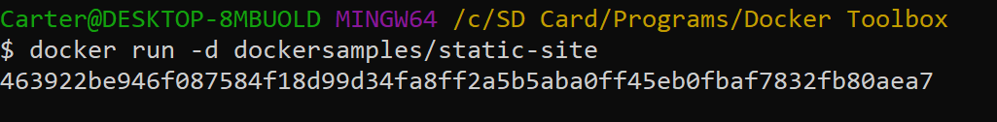

$ docker ps

$ docker stop a7a0e504ca3e

$ docker rm a7a0e504ca3e

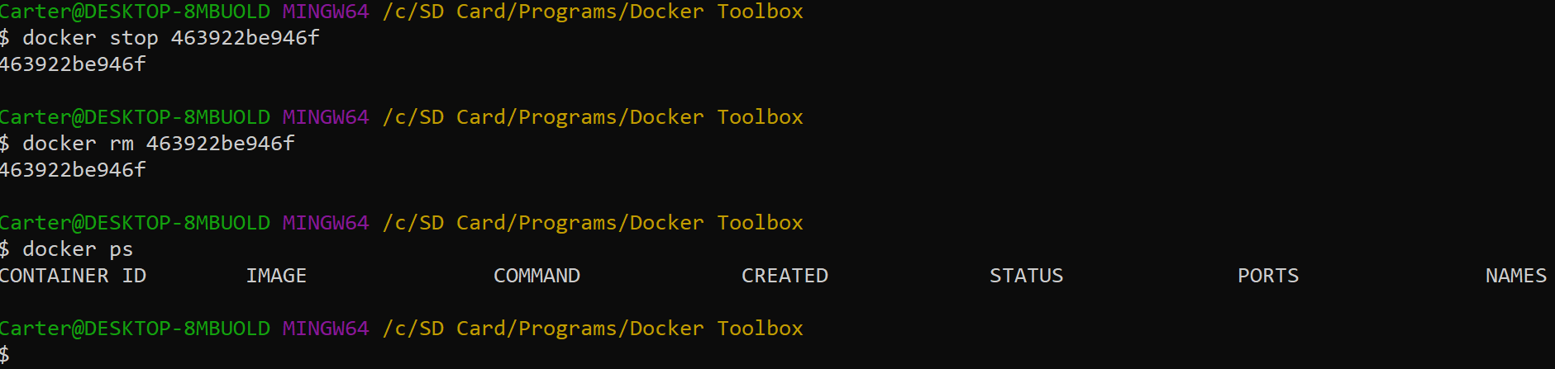

$ docker run --name static-site -e AUTHOR="Your Name" -d -P dockersamples/static-site 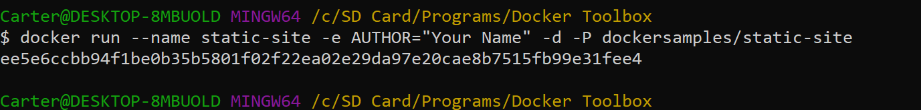

$ docker port static-site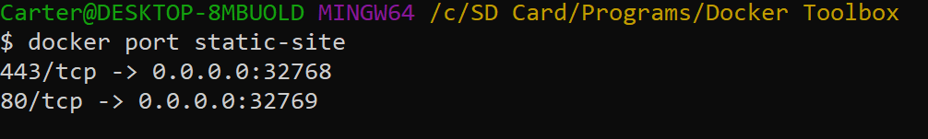

$ docker-machine ip default 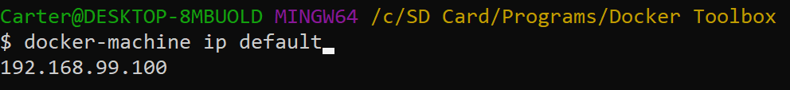

http://<YOUR_IPADDRESS>:[YOUR_PORT_FOR 80/tcp] 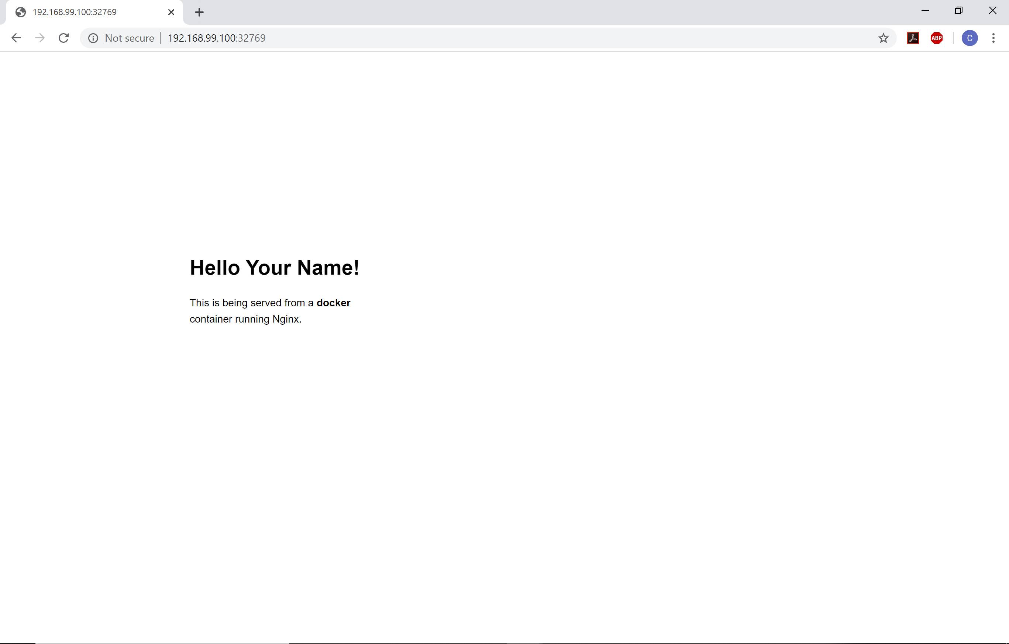

$ docker run --name static-site-2 -e AUTHOR="Your Name" -d -p 8888:80 dockersamples/static-site



$ docker stop static-site

$ docker rm static-site

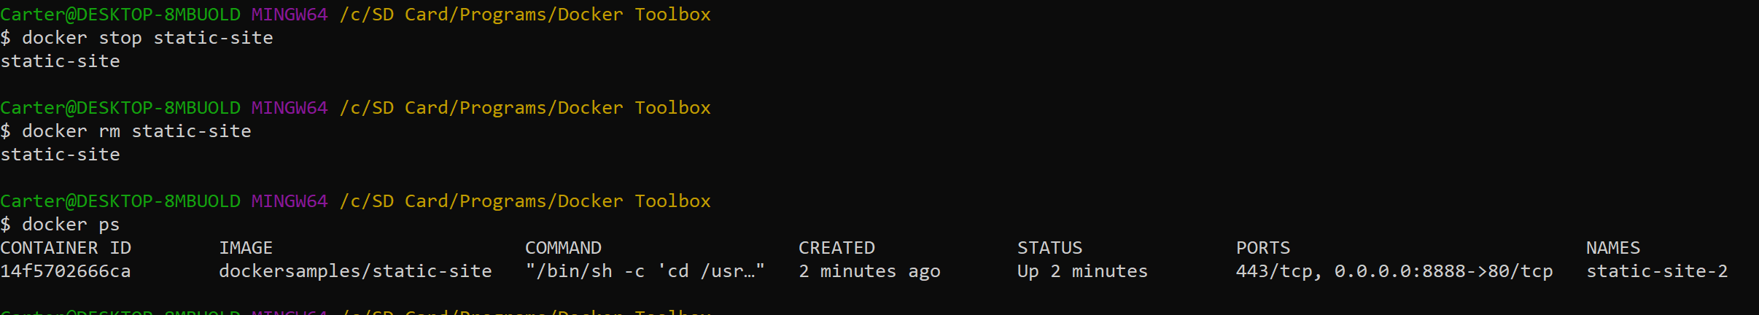

$ docker rm -f static-site-2 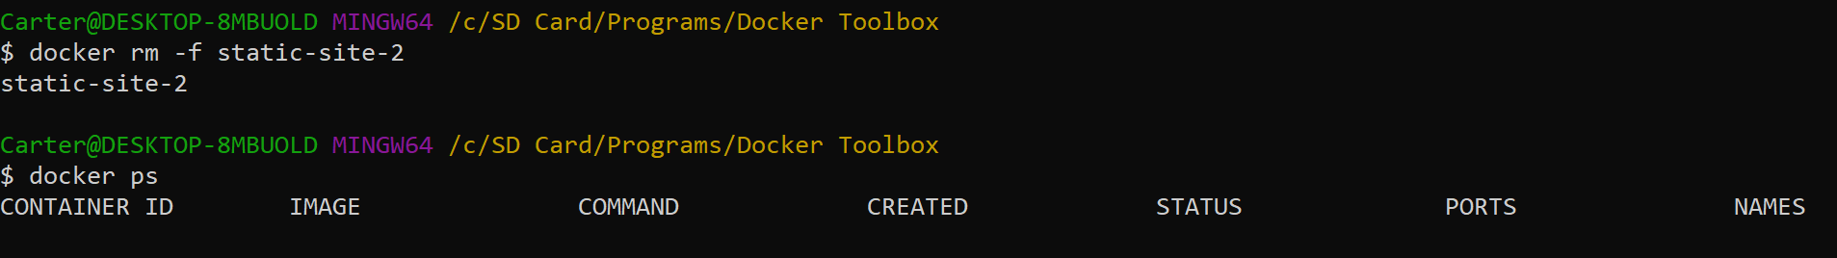

**2.2 Images**

$ docker images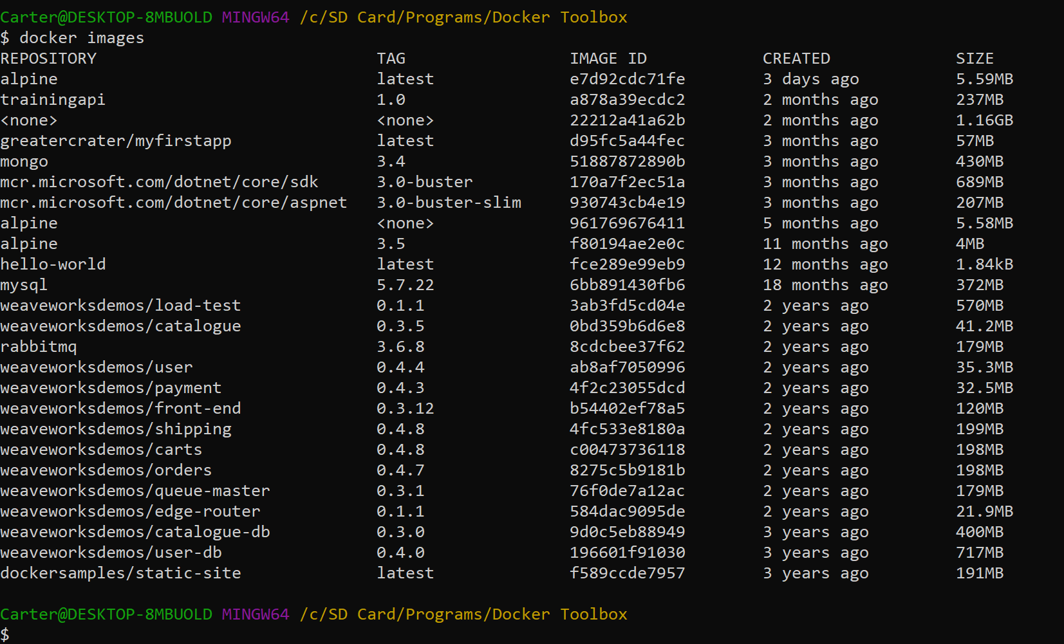

$ docker pull ubuntu:12.04 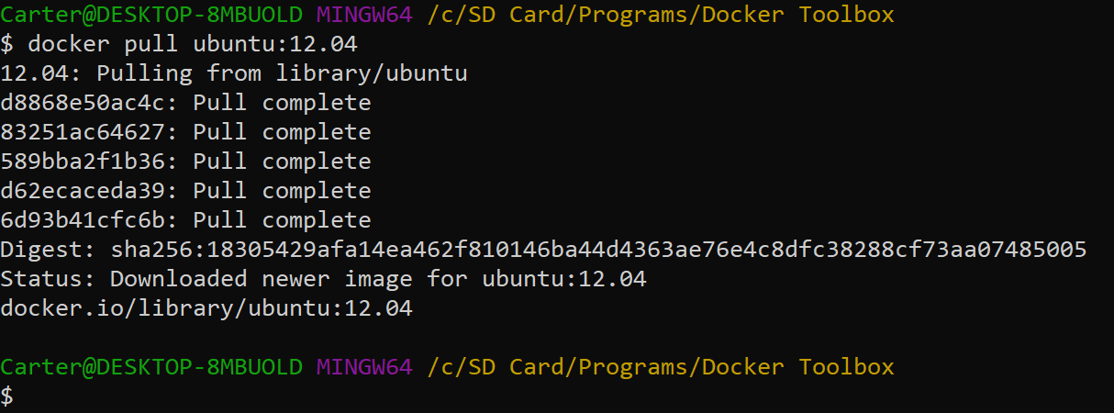

$ docker pull ubuntu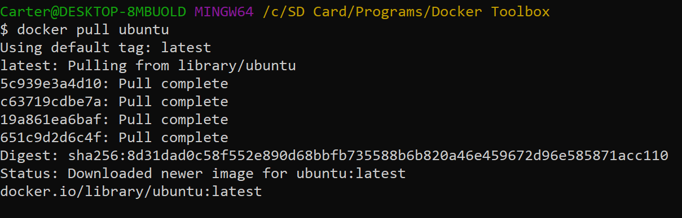

**2.3 Create your first image**

$ docker build -t greatercrater/mysecondapp .

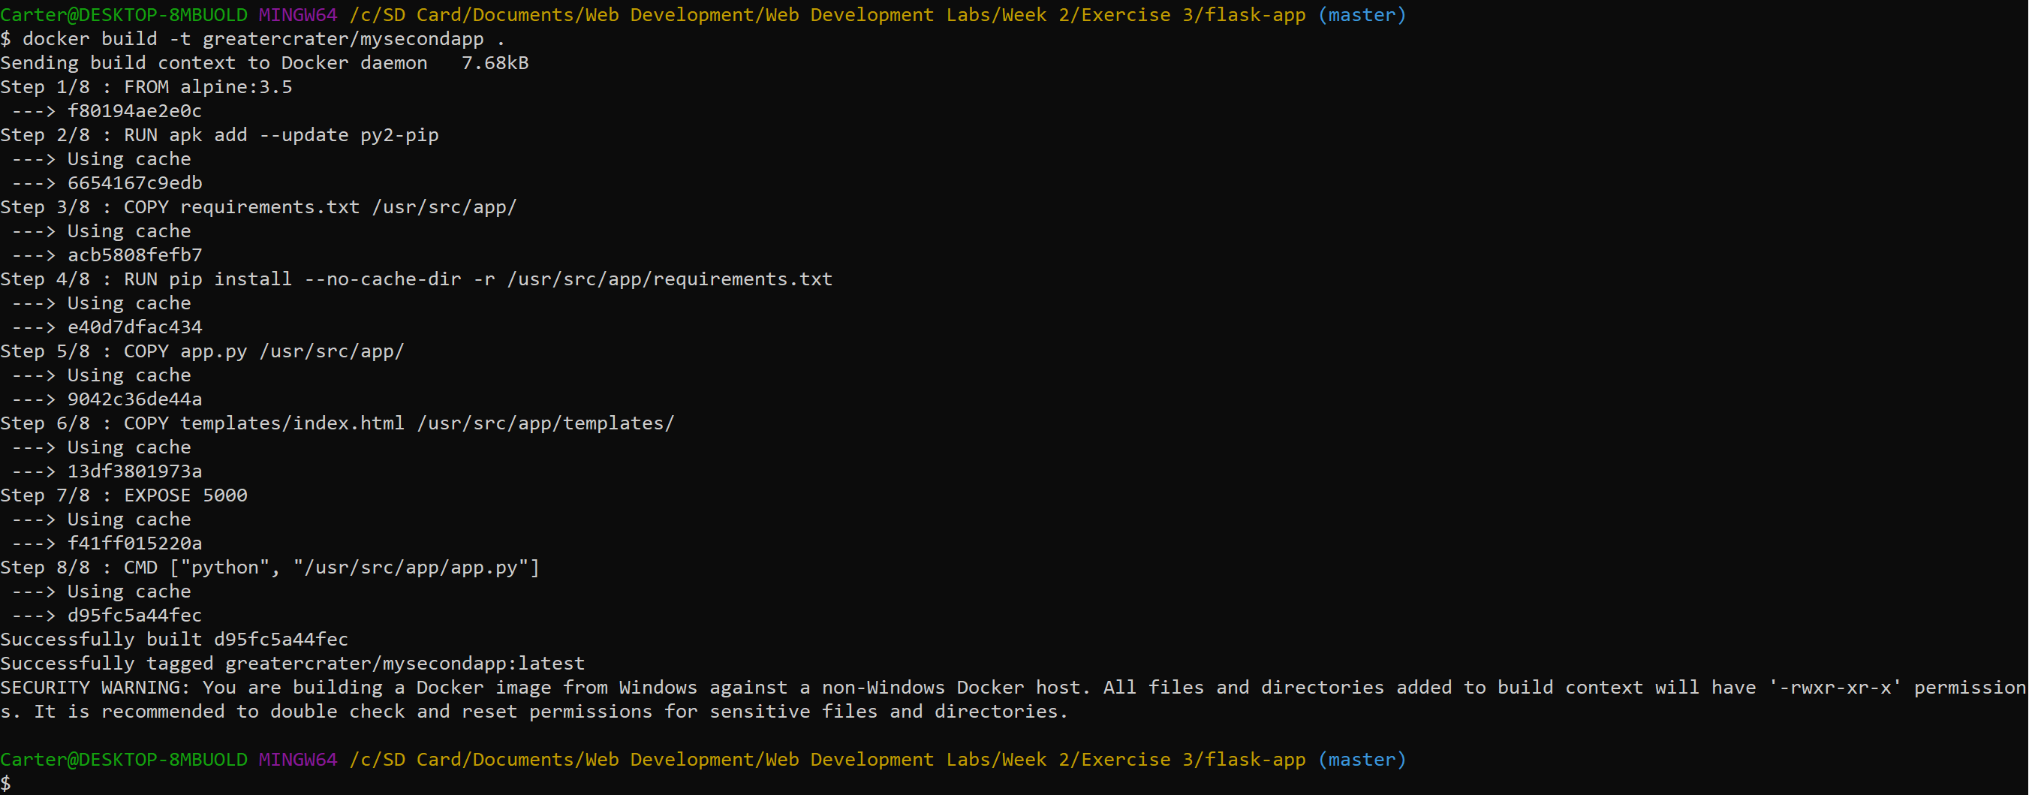

$ docker run -p 8888:5000 --name mysecondapp greatercrater/mysecondapp

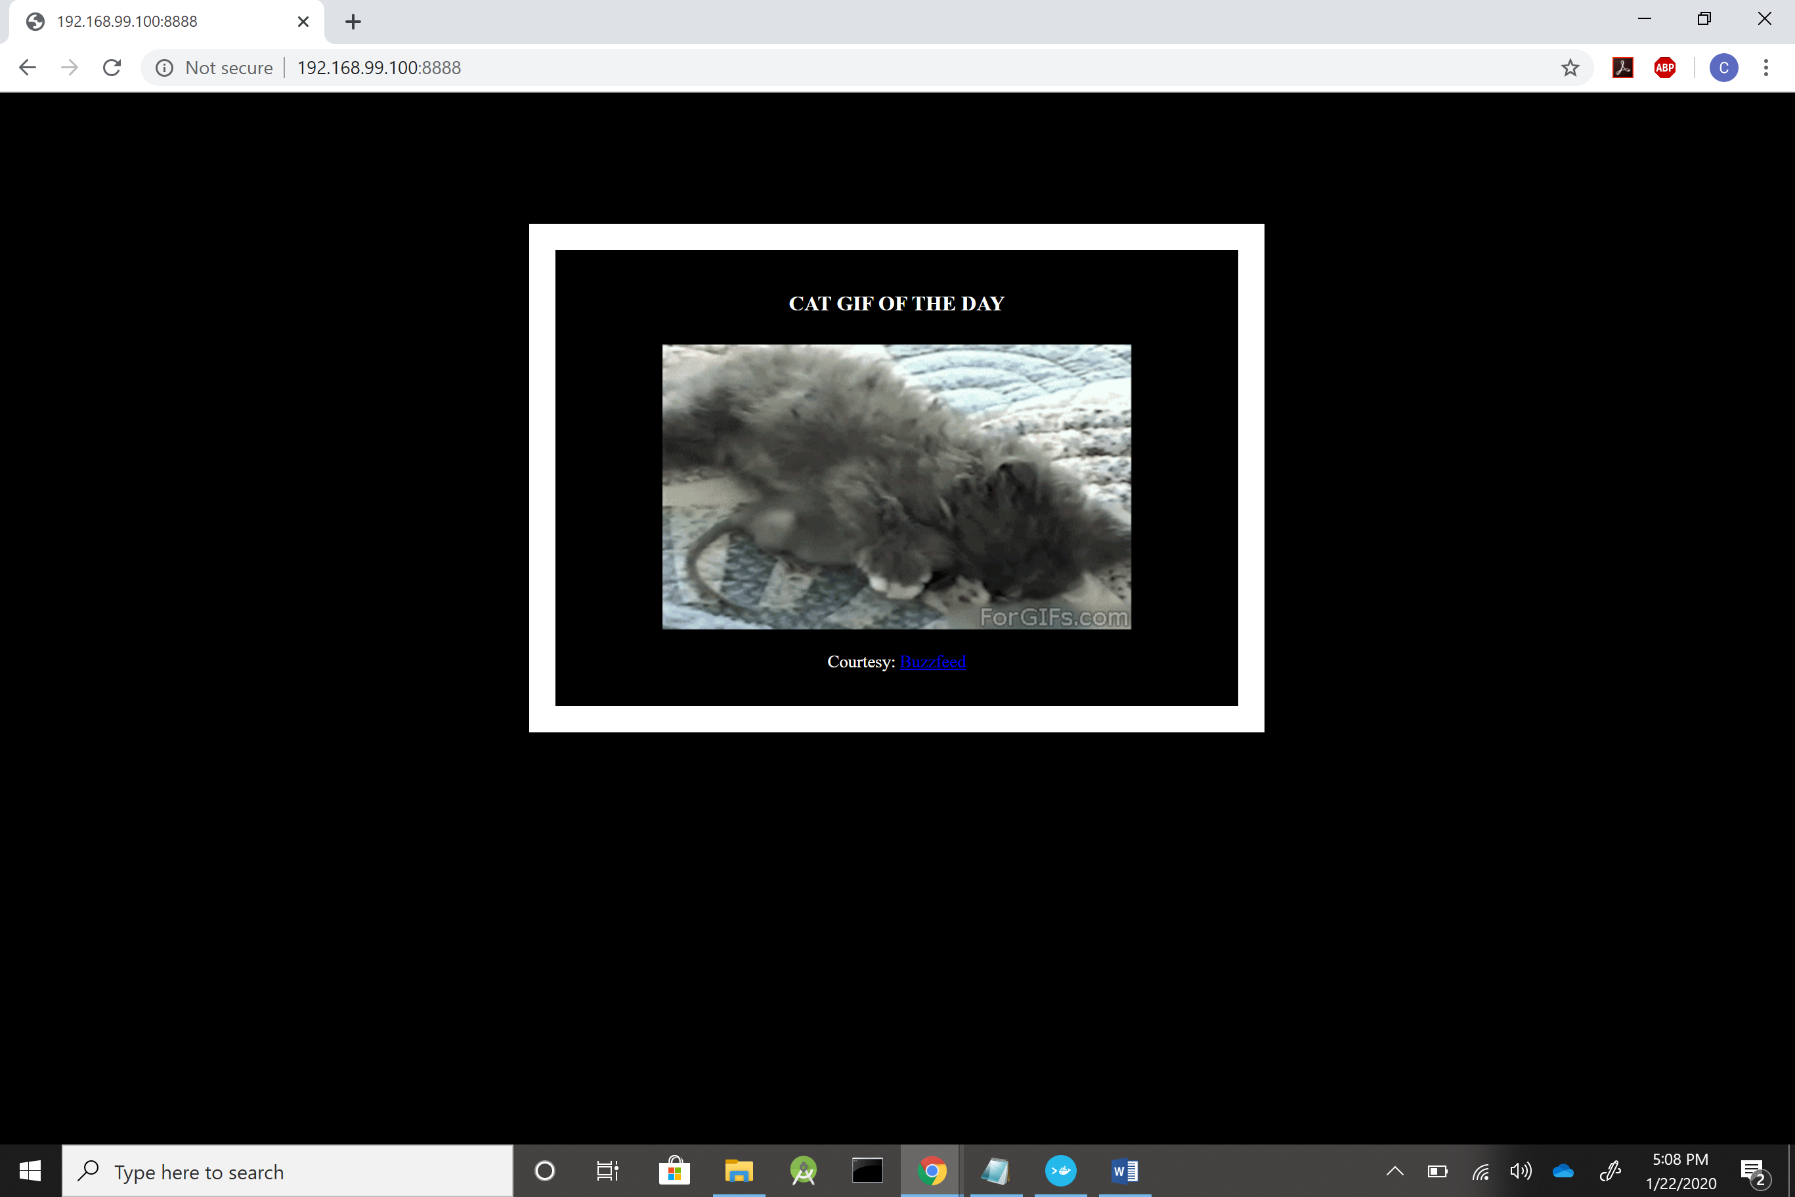

Push to docker:

$ docker login

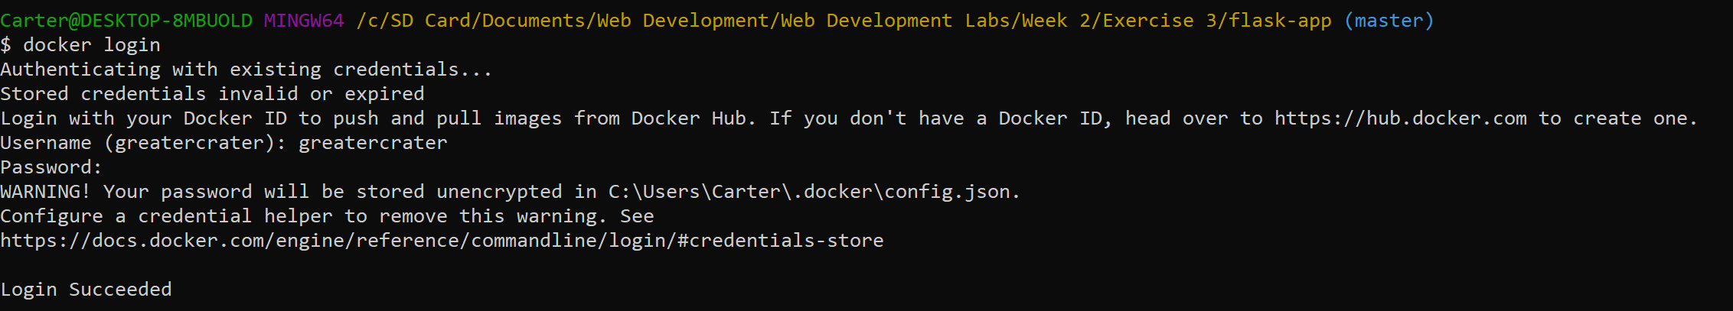

$ docker push greatercrater/mysecondapp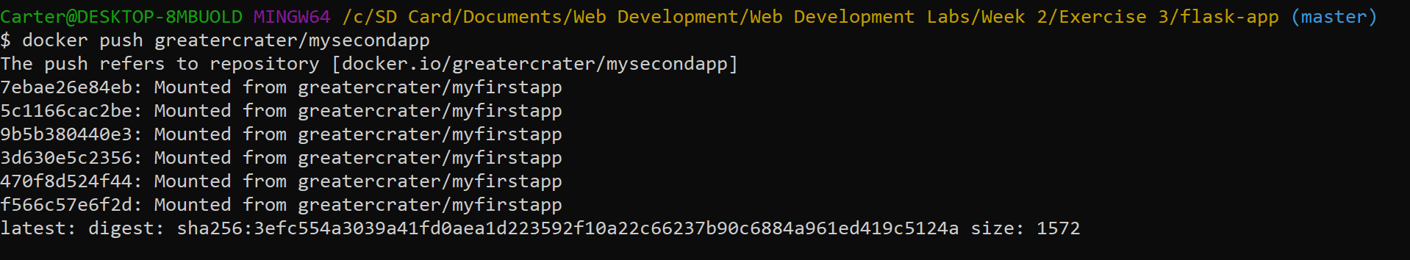

$ docker stop mysecondapp

$ docker rm mysecondapp



**Exercise 4- Your Web Application in a Container**

